**Ideation Phase**

**Define the Problem Statements**

|  |  |
| --- | --- |
| Date | 19 September 2022 |
| Team ID | PNT2022TMID10645 |
| Project Name | Inventory management system |
| Maximum Marks | 2 Marks |

**Customer Problem Statement Template:**

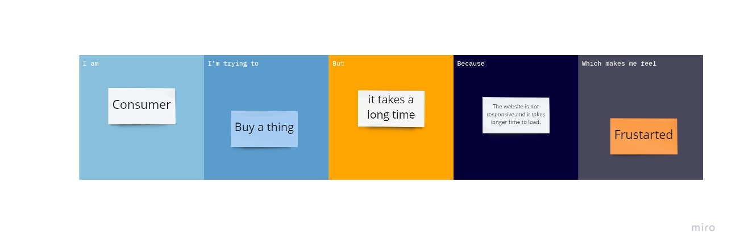

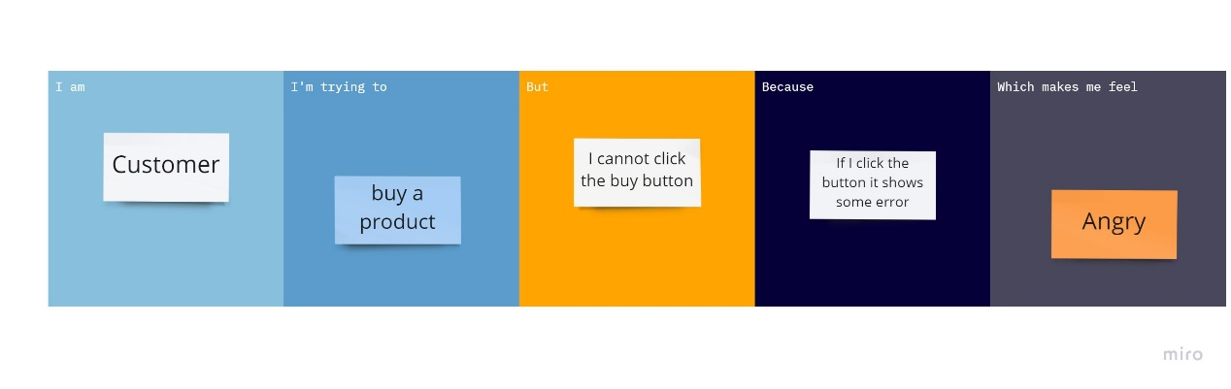

|  |  |  |  |  |  |
| --- | --- | --- | --- | --- | --- |
| **Problem Statement (PS)** | **I am (Customer)** | **I’m trying to** | **But** | **Because** | **Which makes me feel** |
| PS-1 | Consumer | Buy a thing | It takes a long time | The website is not responsive and it takes longer time to load | Frustrated |
| PS-2 | Consumer | Buy a Product | I cannot click the buy button | If I click the button it shows | Frustrated |